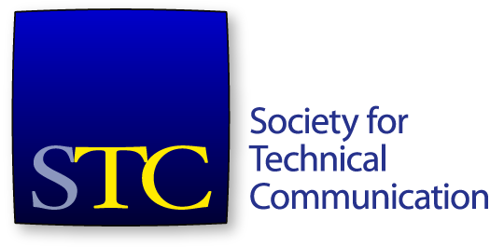
Society for Technical Communication
Board of Directors Meeting Summary
26 September 2019 4:30pm – 6:00 PM EDT, Webinar

Board
- Ben Woelk, President
- Craig Baehr, Vice-President
- Jane Wilson, Immediate Past President
- Kirsty Taylor, Secretary
- James Bousquet, Treasurer
- Bethany Aguad, Director
- Alisa Bonsignore, Director
- Todd DeLuca, Director
- Laura Palmer, Director

Office
- Liz Pohland, STC CEO

Agenda Items
- Technical Communicator Editor search – Laura (10 mins)
- Diversity Advisory Panel – Kirsty (10 mins)
- CPTC – Craig (10 mins)
- IAI discussion (10 min)
- Nominating Committee update - Jane (10 min)
- Treasurer Report – Jim (15 min)
- CEO Report – Liz (20 min)

Consent Agenda
- Approve 29 August Meeting Minutes and Summary
- Approve the chapter name change of the North East Ohio Chapter
The meeting was called to order at 4:30pm. A quorum was established. The agenda was approved. The consent agenda was approved.

Technical Communication Editor Search
Ms Palmer provided an update on searching for a new editor for the journal,

Diversity Advisory Panel Update
Ms Taylor provided an update on the Diversity Advisory Panel charter.

CPTC
Mr Baehr provided a CPTC update. The first round of Practitioner exams have been sent to APMG. Second batch has been written.
Training materials in process for the trainers. A lot of interest in Practitioner.

IAI Discussion
The board discussed recent public information about the closure of the Information Architecture Institute. Could be an opportunity for reviewing our code of conduct, as well as clear and known processes around conduct at or after society events.

Nominating Committee Update
Ms Wilson provided an update on the Nom Com process. Ballot questionnaire was due this past Monday. Several strong candidates have completed their questionnaire. More attrition than expected with the questionnaire.

Treasurer Report
Mr Bousquet presented the financial report to end August 2019. The F&I committee reviewed and accepted August financials on 20 Sept.
Assets – cash down a little on last month, better than Aug 2018. Investments down a little. Total assets $555,460 against $561k in 2018.
Total liabilities - $662,793.
Total net assets $(107,333), better than last year.
Revenue – Webinars continue to be down, unlikely to make EOY budget in the time left. Sponsor numbers are unchanged from July. Total rev $1,428,389. Close to budget.
Likely won’t reach budget on membership dues.
Expenses – Speaker fees favourably under budget. Total expenses $1,194,169 against a budget of $1,370,302.
Operating change in net assets: $208,855 against a budget of $58,087. Total change in net assets $252,812 against $(51,252) in August 2018 and budget of $78,329.
Move that the board accept the financial report for the month of August, 2019.
The motion was seconded. The motion passed.

CEO Report
Ms Pohland presented a report on Society activities.
Membership
At 31 August membership – 3,690 members, down 562 on 2018. Membership revenue is $721,079. $(89,043) behind budget and $(44,336) compared to 2018.
2020 Membership year is open. 23 Sept – 198 members, -67 from last year at this time. Membership revenue is $35k.
Education
Attendance has bumped up a bit. Currently $(65,051) behind budget. Roundtable is not part of Education revenue (it’s a subscription).
Certification
Total 256 passes, 101 failures, and 94 paid and not yet taken. STCCC’s bank balance $11,645.18 with $5k royalties due from APMG. APMG has increased exam pricing.
Roundtable
Main focus of staff work in the last few weeks.
Future Summits
2020 CFP extended through September. Conference committee has plenty of proposals, meeting to select the education program Oct 11-12.
2021 contract signed with Hyatt Regency Atlanta.
2022 – two locations are being considered for mid-May dates.
Resourcing update
Ms Pohland provided an update on the engagement with the third-party, Association Headquarters (AH). STC will be outsourcing various functions to Association Headquarters to improve efficiencies and provide the society with access to additional resources that we don’t currently have in-house, such as marketing expertise.
The meeting adjourned at 5:50pm.

Email votes since the last meeting
Move that the board approve an engagement with Association Headquarters based on an operational model where STC outsources various functions but may retain in-house staff. This model will be subject to review.
The motion passed.
Move that the board approves the STC 2018 990 form, with recommended edits included.
The motion passed.

