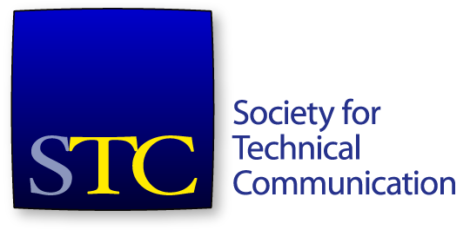
Society for Technical Communication
Board of Directors Meeting Summary
Conference Call
11 March 2016 9:00-11:00 AM CST

Attendees
Board
- Bernard Aschwanden, President
- Adriane Hunt, Vice President
- Alyssa Fox, Secretary
- Jane Wilson, Treasurer
- Kit Brown-Hoekstra, Immediate Past President
- Craig Baehr, Director
- Charles Fisher, Director
- Ray Gallon, Director
- Cindy Pao, Director
Office
- Chris Lyons, CEO
Mr. Aschwanden called the meeting to order at 9:01 AM CST.
A quorum was established. The agenda was approved.

Consent Agenda Items
- Approval of February meeting minutes and summary
The consent agenda was approved with housekeeping changes.

Agenda Items
- Call to order and approval of agenda
- Consent agenda items
- President’s report (15 minutes) – Bernard Aschwanden
- CEO’s report (15 minutes) – Chris Lyons
- Treasurer’s report (15 minutes) – Jane Wilson
- Scholarship task force report (15 minutes) – Ben Woelk
- Fellows vote (15 minutes)
- Competitions discussion (15 minutes) – Bernard Aschwanden
- Executive session (30 minutes) – Board

President’s Report
Ms. Pohland sent out the proposed Intercom awards to the board a few days ago.
A motion was made that the STC board accept the Intercom awards as presented. The motion was seconded. The motion carried.
The Technical Editing SIG asked the board to release their funds since the SIG has no more actions to take at this point to finish their website migration.
A motion was made to release funds to the Technical Editing SIG. The motion was seconded. The motion carried.
The board discussed the issue of who owns content on SIG sites. Mr. Lyons would rather see engaged discussions going on in the SIGs rather than stale posts on a site. This discussion is part of a larger discussion about the role and purpose of SIGs.

CEO’s Report
Mr. Lyons reported on the current state of the society. Membership is down 487 from 2015 at this time, and down 705 from 2014 as of Mar. 7. Most members fall off after 2 years of membership.
The certification program is our biggest bet to get people engaged and stay with us. Membership revenue is down from 2015.
Certification notes:
- As of March 7, 7 are registered, 2 have taken the exam and passed. Two more people have taken the exam since then (one was APMG assessor, so he doesn’t count). So far, no one has registered and failed the exam. The high score has been 39/50.
- Gathering info on entire experience from people who have taken the exam.
- Train-the-trainer class scheduled for April 8.
- Summit prep class and exam sitting set up as a pre-conference event. Alan Houser will be teaching this class.
- Expanding CEU offerings.
- Creating study guide.
- Ms. Pohland and Mr. Lyons are scheduled to give certification presentations to the Puget Sound chapter and to Boeing.
Summit registration continues to be healthy. We currently have 310 registered (had 292 at this point in 2014).
Other items of note:
- Election closing Mar. 11 unless more votes are needed. 428 votes cast so far (just over 13% of membership).
- Audit continues. We are reclassifying some expenses spread over a year’s time as 2015 expenses, cutting into our surplus.
- Discussed Meetup Pro with the Meetup people.
- Movement to the cloud is going well. Virtual servers are up and the iMIS 20 upgrade should be started by the next board meeting.

Treasurer’s Report
Ms. Wilson reported on the January financials. January was a negative month, but that’s not unusual for us. Cash is at $404,577. Total assets are at $938,721. Total liabilities are at $1,137,991. Total net assets are at -$199,270.
A motion was made that the STC board accept the January financials as presented. The motion was seconded. The motion carried.

Scholarship Task Force Update
There was some board discussion about whether STC should continue providing scholarships.

Fellows Vote
The board voted on the proposed Fellows recipients as proposed by the Fellows committee.

Competitions Update
Mr. Aschwanden met with John Hedtke and talked to him about requirements from the board for reworking competitions.

Executive Session
The board entered executive session at 10:33 AM.
The board exited executive session at 11:03 AM CST.

Adjournment
Mr. Aschwanden adjourned the meeting at 11:03 AM CST.

Email Votes Taken Since Last Meeting
The following votes were taken and passed via email since the previous board meeting:
- Vote on the Pacesetter award recipient(s)
- Vote to approve Mr. Lyon’s signing of check for STC Summit AV needs

