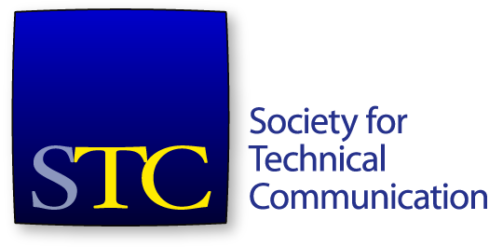
Society for Technical Communication
Board of Directors Meeting Minutes
Conference Call
19 April 2016 11:00 AM – 12:00 PM CDT

Attendees
Board
- Bernard Aschwanden, President
- Adriane Hunt, Vice President
- Alyssa Fox, Secretary
- Jane Wilson, Treasurer
- Kit Brown-Hoekstra, Immediate Past President
- Craig Baehr, Director
- Charles Fisher, Director
- Ray Gallon, Director
- Cindy Pao, Director
Office
- Chris Lyons, CEO
Guests
- Kirsty Taylor, Incoming 2016-17 Secretary
- Alisa Bonsignore, Incoming 2016-17 Director
- Liz Herman, Incoming 2016-17 Director
Mr. Aschwanden called the meeting to order at 11:01 AM CDT.

Consent Agenda Items
- Approval of March meeting minutes and summary
- Creation of Texas State University student chapter
- Approval of Todd DeLuca as 2017 Summit Chair
The consent agenda was approved.

Agenda Items
- Call to order and approval of agenda
- Meeting protocol and consent agenda (Alyssa Fox) – 5 minutes
- President’s report (Bernard Aschwanden) – 5 minutes
- CEO’s report (Chris Lyons) – 10 minutes
- Treasurer’s report (Jane Wilson) – 10 minutes
- Student Twitter competition (Cindy Pao) – 10 minutes
- Audit report (Kit Brown-Hoekstra) – 20 minutes – Executive Session (2015-16 board only)

President’s Report
Mr. Aschwanden reported that he recently participated in Spectrum, the Rochester chapter’s regional conference.

CEO’s Report
Mr. Lyons reported on the current status of the society.
CPTC Foundation updates:
- As of April 15: 9 took exam, 7 registered, 4 signed up for pre-conference course
- Train-the-trainer class occurred April 8 with four trainers – all took and passed Foundation exam
- High score so far – 45/50. 2 failures.
- Creating study guide.
- Richard Johnson-Sheehan recorded webinar on 9 core skill areas – very complementary to CPTC program.
- Liz and Chris gave certification presentations to the Puget Sound chapter and to Boeing.
Summit registration is currently below where we want it. We should make our room block number, though.
Other items of note:
- Audit is complete. It was very thorough but there were few issues.
- Deborah Repasy is no longer at STC.
- Met with Carlos Fulcher, Executive Director of the International Association of Business Communicators.
- Movement to cloud is going well. Virtual servers up and iMIS 20 upgrade is occurring now.
- Texas State University chapter is starting up.
- Reception at Marriott, Monday May 16 at 8 PM, location TBD.

Treasurer’s Report
Ms. Wilson reported on the February financials. Total cash is at $417,593, down from $590,231 at this point last year. Total assets are at $1,034,385. Total liabilities are at $1,298,685. Total net assets at ($259,300).
A motion was made that the board approve the February financials as presented. The motion was seconded. The motion carried.

Student Twitter Competition
The board decided to postpone the discussion about the student Twitter competition until the May board meeting.

Audit Committee Report
Ms. Brown-Hoekstra reported on the status of the audit. The auditors have completed their field work and have praised the staff for their help and openness. The draft report is expected by the end of April. We will need time either before the Summit or at the Saturday board meeting to review the report and accept the results.
The board entered executive session at 11:59 AM.
The board voted to pay Mr. Lyon’s 2014 bonus in monthly payments through the end of 2016.
The board exited executive session at 12:04 PM.
Mr. Aschwanden adjourned the meeting at 12:04 PM.

