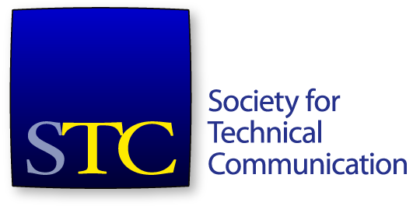
Society for Technical Communication
Board of Directors Meeting Summary
Conference Call
17 August 4-5:30pm US EDT/ 18 August 6-7:30am AEST

Attendees
Board
- Adriane Hunt, President
- Alyssa Fox, Vice President
- Kirsty Taylor, Secretary
- Jane Wilson, Treasurer
- Bernard Aschwanden, Immediate Past President
- Craig Baehr, Director
- Alisa Bonsignore, Director
- Liz Herman, Director
- Cindy Pao, Director
Office
- Chris Lyons, STC Executive Director

Consent Agenda Items
- Approval of July 20 meeting minutes and summary.

Agenda Items
- Call to order and approval of agenda
- Consent agenda item
- President’s report (15 minutes) – Adriane Hunt
- Executive Director’s report (15 minutes) – Chris Lyons
- Treasurer’s report (15 minutes) – Jane Wilson
- Update on Fellows Committee – Larry Kunz via Adriane Hunt (10 minutes)
- SIGs – continue discussion (10 minutes)
- Policy on affiliations with non-STC, non-North American Technical Communication associations – Cindy Pao (20 minutes)
- Nominating Committee update – Bernard Aschwanden (5 minutes)
The meeting started at 4:00pm. A quorum was established.
The agenda was approved. The consent agenda was approved.

President’s Report
Ms Ann Jennings has had to step down from Jay R Gould Committee. Mr Steven Gerson has agreed to replace her.
Ms Hunt will be meeting with committee leads in September.
Ms Hunt established a set of high-level goals for the board to start thinking about and preparing for, which will be discussed at the November face-to-face board meeting.

Executive Director’s Report
Mr Lyons reported on current membership numbers. Membership numbers continue to be down compared to 2015. A new staff member will be joining STC on 24 August in the membership area.
CPTC Update
There have been no further candidates to sit the test since the update on 20 July. We are actively advertising that part of the students’ study strategy should include registering and attending training – the entire sample test is available when you complete training.
The staff are working to schedule more online courses and classes to offer to STC members. Two new courses, Front-End Development & Coding and Tech Editing Foundations, have been well received.
The September issue of Intercom is focused on tools, and will be 16 pages longer than typical longest length.
The contract has been signed with the 2019 Summit venue.

Treasurer’s Report
Ms Wilson presented the financial statement to end June, 2016.
Total cash is $54,436. Year-on-year comparison to 2015 is odd due to Summit timing (the Summit was held in June in 2015). Investments are higher, compared to 2015. Prepaid expenses are higher than 2015; the office rent was paid early due the to holiday weekend in July. Total assets are $703,143.
The total net assets is $80,717. This is down compared to 2015.
For revenue, web seminars are a little bit below they had been budgeted at this stage of the year. There has been a good response to recent seminars, so that may positively impact the webinar revenue.
For expenses, IT support is climbing up. Expenditure on financial services has been down. Actual expenses year-to-date are below budget.
Expenses for the Summit were covered by revenue. More than the typical number of members attended the Summit this year.
Move that the board accept the financials for June as presented. Motion was seconded. Motion passed.

Update on Fellows Committee
The board discussed the progress of the Fellows committee.

SIGs
The board discussed various matters around SIGs. The board determined to include further discussion about SIGs in future meetings.

Policy on Affiliations with non-North American associations
The board discussed the motion about non-North American associations that had passed at the 14 May 2016 face-to-face meeting.
A motion was made that the board revoke the motion on STC's Activities Outside North America adopted at the 14 May 2016 Board of Directors meeting. The motion was seconded. The motion carried.

Nominating Committee Update
Mr Aschwanden gave a general update on the progress of the Nominating Committee in seeking candidates for the 2017 election slate.
The meting adjourned at 5:06pm.

Email Votes in 2016 Year
The following votes were taken and passed via email for the 2016-2017 year thus far.
Move that the board accept the recommendation of the STC staff that Denver be the location of the 2019 STC Summit.
Move that the Board approve the merger of the Suncoast and Orlando chapters.

