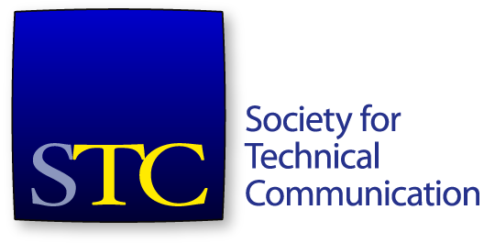
Society for Technical Communication
Board of Directors Meeting Summary
Conference Call
14 September 4-5:30pm US EDT/ 15 September 6-7:30am AEST

Attendees
Board
- Adriane Hunt, President
- Alyssa Fox, Vice President
- Kirsty Taylor, Secretary
- Jane Wilson, Treasurer
- Bernard Aschwanden, Immediate Past President
- Craig Baehr, Director
- Alisa Bonsignore, Director
- Cindy Pao, Director - tick
Office
- Chris Lyons, STC Executive Director – tick
Apologies
- Liz Herman, Director

Consent Agenda Items
- Approval of August 18 meeting minutes and summary.

Agenda Items
- Call to order and approval of agenda
- Consent agenda item
- Executive Director’s report (15 minutes) – Chris Lyons
- Executive Session (75 minutes)
The meeting started at 6:01 pm. A quorum was established.
The agenda was approved. The consent agenda was approved.

Executive Director’s Report
The gap in membership year-on-year continues. The membership arc is similar to last year. Thursday 15 September (tomorrow) is the first day for new membership.
Online class registration has been strong. There tends to be fewer registrants in December classes, so planning on a strong October and November.
The website upgrade and migration project has not been as smooth as anticipated. Some content has not yet been migrated. The highest priority information – that used by general members and renewal information – is ready for 15 September. A key achievement of the new website has been removing the requirement to log in multiple times for Intercom, Technical Communication online, and general STC information. We now have the ability to make certain articles from Technical Communication or Intercom available to the general public; previously only full editions could be made available. Community landing pages are now wikis, which the community leaders can edit directly.
Most issues relating to the iMIS upgrade have been worked out. A new job posting service will be included in the upgrade, which will include more filtering and searching capabilities.
The STC office now has a better internet connection. Servers are being moved to online hosting, which is more stable than the current physical setup. Internet access speed has been dramatically improved.
Ideas about communities updating their landing pages were discussed.
Good news for the Technical Communication journal – the editor, Sam Dragga, has sufficient material to go through to 2018.
The Summit Call for Proposals is going well. The committee is currently seeking approximately 100 proposals. The intent is to have those who submit proposals focus on their best possible proposals by limiting the number of proposals possible from an individual.
Erin Gallalee has joined STC as the new membership manager.
The CPTC is a requirement for a recent Corps of Engineers RFP. Six different firms have contacted STC about trying to find firms with CPTC experts.
The staff are investigating a new accounting firm to replace Renner.
Mr Lyons left the meeting at 4:19pm.

Executive Session
The Board entered executive session at 4:19pm.
The Board discussed matters relating to Mr Lyons’ resignation.
The meeting adjourned at 5:31pm.

Email Votes in 2016 Year
The following votes were taken and passed via email for the 2016-2017 year thus far.
Move that the board accept the recommendation of the STC staff that Denver be the location of the 2019 STC Summit.
Move that the Board approve the merger of the Suncoast and Orlando chapters.
Move that the Board dissolve the Willamette Valley chapter at the end of the 2016 membership year.
Move that the STC Board accepts Chris Lyons's offer of an additional 140 hours of leave in lieu of cash for his 2015 bonus.
Move that the STC board accept Liz Pohland and Stacey O’Donnell’s proposal for them to serve as interim CEO and COO respectively, with the COO reporting to the CEO and CEO reporting to the board, with salary adjustments to be defined within two weeks.
Move that the Board approve the renaming of the Orlando-Central Florida Chapter to the Central Florida Chapter
Move that the Board formally dissolve the following communities:
- Kachina Chapter
- Central Iowa Chapter
- Content Life Cycle SIG
- Australia Chapter

