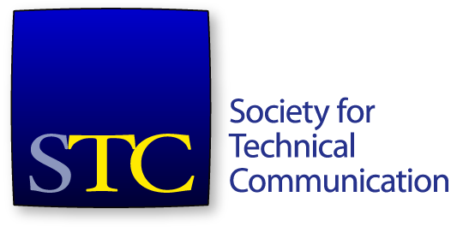
Society for Technical Communication
Board of Directors Meeting Summary
27 March 2019 5:00 PM – 6:30 PM EDT

Board
- Jane Wilson, President
- Ben Woelk, Vice-President
- Alyssa Fox, Immediate Past President
- Kirsty Taylor, Secretary
- James Bousquet, Treasurer
- Alisa Bonsignore, Director
- Todd DeLuca, Director
- Jessie Mallory, Director
- Robert Perry, Director

Office
- Liz Pohland, STC CEO

Agenda Items
- Treasurer’s Report – Jim Bousquet 35 min
- CEO Report – Liz Pohland 20 min
- Summit Update – Jane Wilson 10 min
- SIG Taskforce Update – Ben Woelk 10 min

Consent Agenda
- Approve February meeting minutes and summary.
- Approve the committee’s recommendations for recipients of the 2018 CAA Pacesetter awards.
- Approve the committee’s recommendation for the recipient of the 2018 Frank R.Smith award.
The meeting was called to order at 5:02pm. A quorum was established. An addition to the agenda was made – an update to the CAA awards. The agenda was approved. The consent agenda was approved.
Treasurer’s Report
Mr Bousquet presented the January 2019 financial report.
Total assets: $783,607. Liabilities $1,152,602.
Ms Bonsignore joined the meeting at 5:05pm.
Total net assets $(368,994).
Revenue $76,648. Expenses $106,487.
Operating change in net assets $(29,839). Total change in net assets $(8,847). Better than budget.
Move that the board accept the financial report for the month of January 2019.
The motion was seconded. The motion passed.
Mr Bousquet presented the financial report for February 2019.
Assets - $898,326. Liabilities $1,311,089. Total net assets $(412,763). Revenue $146,293.
Mr Perry joined the meeting.
Expenses - $228,417. Operating change in net assets - $(82,124). Total change in net assets $(52,617). Better than budget.
Move that the board accept the financial report for the month of February 2019.
The motion was seconded. The motion passed.
Mr Bousquet presented further financial information.
CEO Report
Membership at 24 March – membership is down. 3,016 members, around 400 fewer than last year at this time. Details of membership by category were presented.
Education
Revenue is down, $19k behind budget, but attendance is higher.
Roundtable update
An update on the Roundtable initiative and progress throughout March was presented.
- Website traffic is up, especially on days with email campaigns.
- Email campaigns have a high open rate.
- Social media traffic is up.
- Good registration rates, around 50-60% attending.
- Mostly positive feedback on webinars.
- April content is being prepared.
Summit
As of Monday, have 540 registrations, with $410,487 in revenue. Tracking ahead of registration of the last four years. All workshops are super popular Kudos to the conference committee, who have been promotion on social media, and so on.
Certification
About $12k (total) in revenue for the certification commission.
General updates
Office has moved! Went successfully.
2018 audit almost completed.

CAA change
Mr DeLuca provided an update on a request from the CAA committee. The committee re-evaluated applications, and had one amendment.
Move that the board accept the committee’s recommendation to increase the CAA award level of one recipient.
The motion was seconded. The motion was discussed further.
The motion was withdrawn. Further information will be sought from the committee, and discussion will continue in email.

Summit Update
Ms Wilson presented an update on the Summit schedule, and expectations for the board during the Summit.
Having an orientation for new board members next week. Current board will be invited to attend.

SIG Taskforce/Initiative
Mr Woelk discussed progressing the SIG taskforce.
The meeting adjourned at 6:13 pm.

Email motions since the last meeting
Move that the board approve the honoree for membership in the Sigma Tau Chi (STX) honor society.
The motion passed.
Move that the board approve the committee's recommendations for the 2018 Community Achievement Award recipients.
The motion passed.

