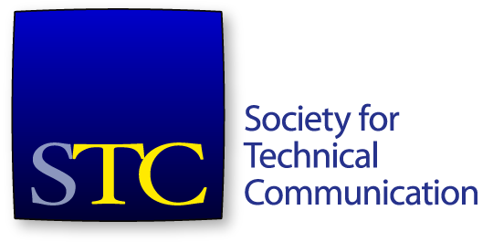
Society for Technical Communication
Board of Directors Meeting Summary
Conference Call
21 December 4-5:30pm US EST/ 22 December 7-8:30am AEST

Attendees
Board
- Adriane Hunt, President
- Alyssa Fox, Vice President
- Kirsty Taylor, Secretary
- Jane Wilson, Treasurer
- Bernard Aschwanden, Immediate Past President
- Craig Baehr, Director
- Alisa Bonsignore, Director
- Liz Herman, Director
- Cindy Pao, Director
Office
- Liz Pohland, STC Interim CEO
- Stacey O’Donnell, STC Interim COO

Agenda Items
- Call to order and approval of agenda
- President’s Report (10 minutes) – Adriane Hunt
- Interim CEO / COO report (15 minutes) – Liz Pohland and Stacey O’Donnell
- Communication with Nominating Committee (30 minutes) – Bernard Aschwanden

The meeting commenced at 4:01 pm.
A quorum was established. The agenda was approved. There was no consent agenda.

President’s Report
Ms Hunt gave an update on the strategy discussions from the November Face-to-Face meeting. Ms Hunt would like to discuss more at our January meeting. Ms Hunt asked everyone to review the spreadsheet and nominate for individual areas of work.
Ms Hunt is working on board member on-boarding materials. Her aim is to bring materials to the February meetings for review in preparation for the new board and handing over to a new President for 2017-2018. Mr Brian Lindgren has offered to help review documents. Ms Wilson discussed those in specific roles such as Treasurer and Secretary may want to prepare role-based documents about the specifics of those roles.
Ms Hunt wished the board a Happy Holidays.

Interim CEO/COO Report
Ms Pohland thanked the board personally for their gift of snacks to the staff this week for the holidays.
CPTC update
The staff have met with the iMIS vendor about the membership module to investigate tracking CEUs.
RFPs have been received for the pre-conference CPTC course from the certified trainers. Ms Pohland is reviewing; she commented that the RFPs were of a high quality and the choice will be hard.
Education revenue
YTD revenue is very close to $200k
Membership
Still hovering around 500 person gap on last year. Renewals are coming in.
90 members have renewed in last two days. At least 200 CVPs have agreed that they are renewing this year. There is normally quite a spike in membership on 31 December.
Summit update
Registrations for Summit are on par with last year.
Invited speakers – Mr DeLuca has been given a list of recommendations for invited speakers. Ms O’Donnell is working closing with him on that list.

Communications with the Nominating Committee
The board discussed assorted matters relating to the Nominating Committee and the upcoming society election.
The meeting adjourned at 4:54pm.

Email votes since the last meeting
The following votes were taken and passed via email since the last board meeting.
Move that the board accepts the recommendations of the DCA committee for the awards to be given.

