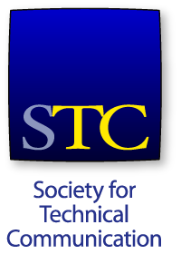

Application for Community Pacesetter Award

Date

Community Name

Brief description of your Community’s innovative activity:

How does this activity further the goals of the Society and/or the Community:

Could other Communities replicate your success with this activity? If so, how?

Name:
E-mail Address:
Daytime Phone:

The Community Pacesetter Award Application is due on 24 March 2017. The application should be e-mailed to MaryKay Grueneberg, Community Pacesetter Award Chair, marykay.stc@gmail.com and to Elaine Gilliam, Meeting Manager/Community Relations at Elaine.Gilliam@stc.org.

Winners will be announced at the 2017 STC Summit.

