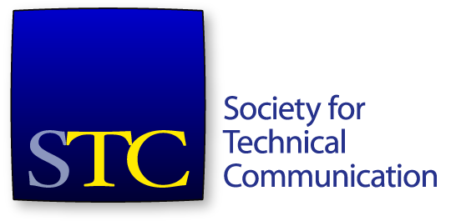
Society for Technical Communication
Board of Directors Meeting Summary
21 January 2020 - Webinar

Board
- Ben Woelk, President
- Craig Baehr, Vice-President
- Jane Wilson, Immediate Past President
- Kirsty Taylor, Secretary
- James Bousquet, Treasurer
- Bethany Aguad, Director
- Alisa Bonsignore, Director
- Todd DeLuca, Director
- Laura Palmer, Director

Office
- Liz Pohland, STC CEO

Agenda Items
- CEO Report (20 mins)
- President Report (5 mins) - Ben
- Frank R Smith (5 mins) - Laura
- Associate Fellows (5 mins) – Craig
- Fellows (5 mins) – Alisa
- Executive Session (60 mins) – Board only
The meeting was called to order at 4:30pm. The agenda was approved. The consent agenda was approved.

CEO Report
Ms Pohland presented a report on activities of the society and its office.
Membership
As of Sunday, 1,810 members for 2020. About 500 less than 2019 at this time.
Education
37 attendees with $8,212 in revenue. A lot of courses are online, but weak in webinars. Ms Banner is starting next week and her first priority will be to arrange more webinars.
Summit
Summit revenue tracking similarly to last year.
Certification
275 passes of CPTC and 111 failures. 90 ppl in queue to take exam. Overall pass rate is 72%. 333 member exams, 39 nonmember exams to date. Pass rate has fallen a bit.
Association Headquarters MarCom update for Dec, 2019
AH started managing our most popular social media accounts from 1 Dec. Had a little bit of growth in 2019. Looking at social ads.
Discussed specifics of social media attention in Dec, 2019.
Discussed email campaigns – Constant Contact (non-membership) and Mailchimp (membership emails).
General updates
Our new Director of Education, Phylise Banner, is starting on 27 Jan. Spending first two weeks in the office, she will be working remotely.
AH partnership will be announced to the membership via blog the week of 27 Jan.
Cash flow is back on track. All invoices up-to-date.
Several IR meetings last week.
Ms Pohland presented a list of the AH staff who she is working with across the various functions that AH is providing to STC.

President Report
Mr Woelk provided an update.

Frank R. Smith Award Recommendation
The committee has proposed a recipient for the frank R Smith award.
Move that the board accept the committee’s recommendation for the 2020 Frank R. Smith Award recipient.
The motion was seconded. The motion passed.

Associate Fellows
Mr Baehr presented the committee’s recommendations for Associate Fellow recipients for 2020.
Move that the board accept the committee’s recommendations for the 2020 Associate Fellows.
The motion was seconded. The motion passed.

Fellows
Ms Bonsignore presented the recommendations for the Fellow recipients for 2020.
Move that the board accept the committee’s recommendations for the 2020 Fellows.
The motion was seconded. The motion passed.
Ms Pohland left the meeting at 5:11pm.
The board entered executive session at 5:12pm. The board left executive session at 6:09pm.
The meeting adjourned at 6:09 pm.

